MuleSoft Runtime Upgrade Tool
For the Mule runtime upgrade project below two custom tools are created in java.

Mule App Validation Tool - Muleguard:
About:
MuleGuard is a comprehensive static analysis java tool designed specifically for MuleSoft applications. It automates the validation of Mule projects against a defined set of coding standards, security best practices, and migration/upgrade readiness requirements.
Challenges:
- Migration Complexity: Version upgrades, JDK 17 compatibility, security compliance, dependency management
- Manual Review Inefficiency: Time-consuming manual checks across multiple files and projects
- Common Pitfalls: Specific examples of issues detected (unsupported error expressions, deprecated dependencies, security vulnerabilities, missing configurations)
Benefits and Effort Savings:
- Quantifiable Time Savings Table: Shows 99%+ time savings across all validation activities
  - Manual effort: 2.5-3.5 hours per API
  - MuleGuard: < 5 seconds per API
  - For 100 APIs: 250-350 hours → < 10 minutes
- Quality Improvements: 100% rule coverage, consistency, early detection
- Operational Benefits: Accelerated migration, risk mitigation, CI/CD integration
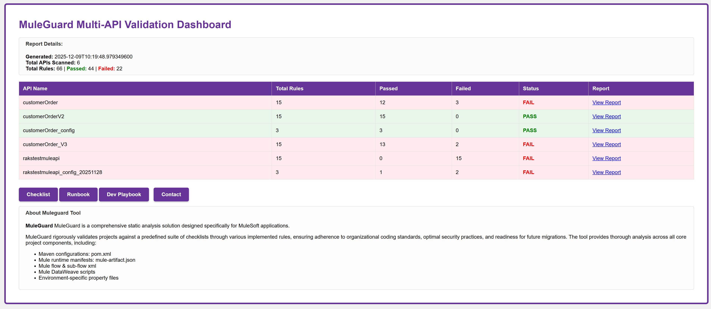
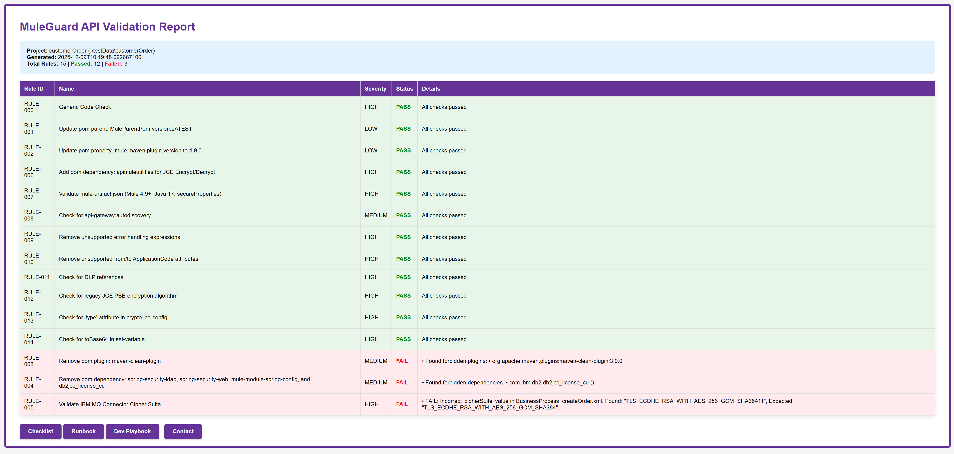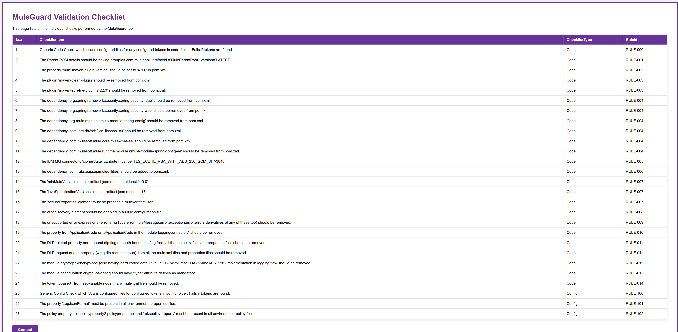

Mule App Testing Tool – APITestingGuard:
About:
APITestingGuard is a Java-based testing tool with both web GUI and command-line interfaces. It automates API response comparison for REST and SOAP services, supporting live endpoint comparison and baseline integration testing with automated iteration across multiple test scenarios.
Challenges:
When teams upgrade APIs, migrate infrastructure, or refactor services, subtle response changes often slip through traditional testing and break downstream integrations in production. Manual testing can't cover all edge cases, and teams lack visibility into how API behaviour changes between versions or environments.
Benefits and Effort Savings:
The tool eliminates manual API testing by automatically comparing tens/hundreds or even more of response combinations in minutes. Teams can validate upgrades with confidence by capturing pre-upgrade baselines and comparing against post-upgrade responses. The tool catches breaking changes before deployment, reducing production incidents and the costly firefighting that follows. For organizations managing multiple API versions or performing frequent releases, this translates to significant time savings and reduced risk of customer-impacting outages.
